Visual Builder Studio Documentation

Contents

Visual Builder Studio 1
1. Introduction 3
2. How Do I Set Up VB Studio? 4
3. Key Concepts, Components, and Terms 5
4. OCI Resources in VB Studio 10
5. Set Up Oracle Visual Builder Studio Generation 2 13
6. IAM Policy Details for VB Studio 13
Service Events 16
7. Get the Right IDCS Roles 17
8. Configure Client OCI Resources for CI/CD 17
9. Create an OCI Compartment 18
10. Create the VB Studio Instance 18
11. Access VB Studio from the Oracle Cloud Home Page 20
12. Manage the VB Studio Instance 22
13. Change the CI/CD Compartment 22
14. Switch to the Built-In Free Account 22
15. Manage VB Studio Instance Tags 22
16. Terminate the VB Studio Instance 23
17. Get a VB Studio Project's Identifier 24
18. Set Up VB Studio for CI/CD 24
19. What are Build Executors and Build Templates? 24
20. Build Executor Templates 25
21. VM Build Executors 25
22. What Happens When a Build Runs in a Build Executor? 28
23. VB Studio's Free VM Build Executor 29
24. Run VM Build Executors in Virtual Cloud Network 30
25. Run VM Build Executors in Another Compartment's VCN and Subnets 32
26. Set Up the OCI Account 33

Introduction

Oracle Visual Builder Studio brings client all the functionality previously available with Oracle Developer Cloud Service and Oracle Visual Builder, along with the ability to extend certain Oracle Cloud Applications to customize the UI for client business needs.
Oracle Visual Builder Studio (VB Studio) is a robust application development platform that helps client team effectively plan and manage client work throughout all stages of the app dev lifecycle: design, build, test, and deploy.
In addition, VB Studio makes it easy for client entire team to develop the artifacts they need, including:
- Oracle Cloud Applications developers, who need to extend their applications with business-specific customizations;
- Low-code developers, who want to create web or mobile apps using a visual designer;
- Experienced programmers, who want to modify the source code for web and mobile apps created by others, or to develop bespoke apps using the web programming language of their choice.

How Do I Set Up VB Studio?

Using VB Studio's hosted development and delivery platform, client and client team can develop software applications using any language client choose. Client can also extend certain Oracle Cloud Applications by creating extensions, which are managed just like any other VB Studio artifact.
Before client team can use VB Studio client, as the administrator, must set it up and configure it. Client must also add client team members to Oracle Identity Cloud Service (IDCS) and assign them proper roles.
Only one IDCS is supported per service instance.
Setting Up for Visual Applications
Here's an overview on how to set up VB Studio for developing visual web or mobile applications:
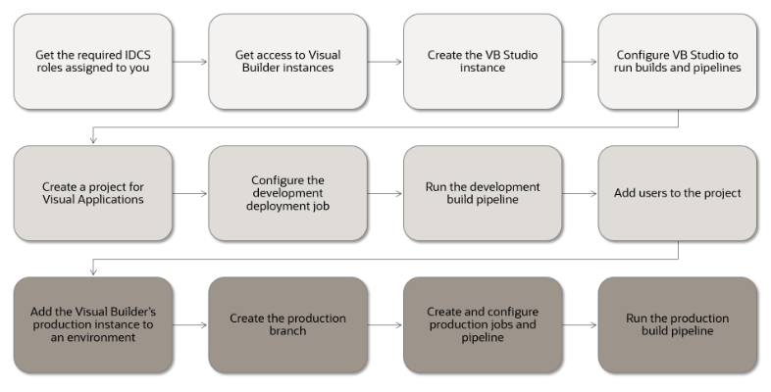

Setting Up for Application Extensions
Here's an overview on how to set up VB Studio for developing extensions to customize Oracle Cloud Applications:
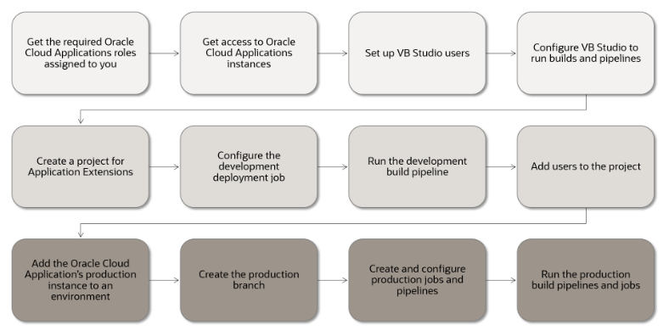
Setting Up for Other Applications
Here's an overview on how to set up VB Studio if client team develops applications using popular build frameworks such as Maven, Gradle, Ant, and Node.js; or uses standard infrastructure interfaces such as Docker, Kubernetes, and Terraform:
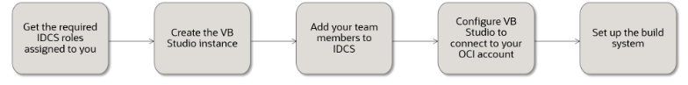

Key Concepts, Components, and Terms
Before client use VB Studio, it helps to become familiar with these key concepts, components, and terms. (If client have general questions about Oracle Cloud features and services,.)
Term | Description
Oracle Cloud Infrastructure (OCI) | Oracle Cloud Infrastructure is a set of cloud services that enable client to build and run a wide range of applications and services in a highly available hosted environment. Oracle Cloud Infrastructure offers high-performance compute capabilities (as physical hardware instances) and storage capacity in a flexible overlay virtual network that is securely accessible from client on-premise network.
Oracle Cloud Infrastructure Compute (OCI Compute) | Service that hosts virtual machines (VMs) on Oracle Cloud with all the necessary storage and networking resources. VB Studio uses the VMs to run project builds.
OCI Compute VM instance | A virtual machine that runs on top of physical bare metal hardware.
OCI Compute VM shape | A shape is a template that determines the number of CPUs, amount of memory, and other resources allocated to a newly created VM compute instance.
OCI region | OCI is hosted in regions and availability domains. A region is a localized geographic area, and an availability domain is one or more data centers located within a region.
OCI Virtual Cloud Network (VCN) and subnets | A VCN is a software-defined network that client set up in Oracle Cloud Infrastructure data centers in a particular region.
Oracle Cloud Infrastructure Object Storage (OCI Object Storage) | Oracle Cloud service that hosts containers on Oracle Cloud to store project data. VB Studio uses the buckets to archive build artifacts and Maven artifacts, and export project data.
Oracle Cloud Applications | Oracle Cloud Applications are a set of modular Cloud-ready enterprise applications. To learn more, see https://www.oracle.com/applications/.
Application extension (App UI) | An App UI is an application that includes a user interface component in the form of Visual Builder pages and flows. Some App UIs are created by Oracle—like some Oracle Cloud Applications—but client can build client own App UIs and deploy them as peers alongside Oracle’s App UIs in client Oracle Cloud Applications ecosystem.
Visual Builder | A Visual Builder instance that provides the server for delivering pages in web applications, and services client web and mobile apps might use to access data, including the database used to store data and the proxy server for managing connections to REST services.
Visual application | A responsive web or native mobile application developed using VB Studio's browser-based development environment.  Client deploy a visual application to a Visual Builder instance.
Project | A project is a collection of VB Studio features.  Client can use a project to host source code files, track issues, collaborate on code, build, and deploy client applications. A project can host multiple Git repositories. Each Git repository can have multiple branches and hundreds of code files. Client can create a merge request for each branch of the Git repository and ask reviewers to review the code. Client can create and configure multiple build jobs to generate different project artifacts that client can deploy to Oracle Cloud or client on-premise web server.
Organization | The top-most entity in the project structure of VB Studio. Think of an organization as the umbrella for all the projects in a given identity domain.
VB Studio Designer | VB Studio's browser-based development environment.
Git repository | A Source Code Management (SCM) and distributed version control tool to host source code files.
Maven repository | A hosted binary repository to store build artifacts, library files, and dependencies for Maven applications.
Issue tracker | A built-in issue management system to create and track tasks, defects, and features.
Environment | Defines the target Oracle Cloud Applications, Visual Builder, Oracle Cloud SaaS, or Oracle Cloud Infrastructure service instance as a single entity. Client define an environment to deploy an application to a service instance or to get information from a service instance.
Merge request and code review | A method to merge a Git repository branch with another branch. Before merging the branches, team members can review differences between files of both branches and provide their feedback.
Wiki | Built-in wiki system to help client team author and manage wiki pages.
Build system | A built-in system to define and automate builds of client applications.
Continuous Integration (CI) and Continuous Delivery (CD) | Continuous integration is a set of practices that allow development teams to implement small code changes and push the code to version control repositories, such as Git, frequently. Continuous delivery is a practice that enable developers to produce software in short cycles.
VM build executor | An OCI Compute VM instance dedicated to run VB Studio builds. Only one build can run on a VM build executor at a time.
Build executor template | A template that defines the operating system and the software installed on a VM build executor.
Docker image | Defines the operating system and software packages client organization needs to run builds on a Docker executor. A Docker image can be either imported from an external Docker registry or created from a build executor template.
Docker deployment VM | An OCI VM compute instance dedicated to run builds of jobs defined in VB Studio projects using Docker executors.
Docker executor | When a job is created, a Docker image is associated as a build template with the job. Then, when the job's build is triggered, a Docker executor is created using the Docker image and deployed on any Deployment VM to run the build. Unlike a VM executor, a Docker executor is not directly associated with a specific VM.
Job (or build job) | A configuration that defines client application's builds.  Client can create a job to perform various actions, such as package artifacts, run shell commands, run unit test scripts, and deploy application artifacts.
Build | The result from a job’s run.
Pipeline | A path or a chain of builds. A pipeline helps client run continuous integration jobs and reduce network traffic.
Oracle Java Cloud Service | Oracle Cloud service to deploy web applications to a public Oracle WebLogic Server domain on Oracle Cloud.

OCI Resources in VB Studio
In VB Studio, client use continuous integration and continuous delivery (CI/CD) build jobs to package and deploy client application. To run builds, VB Studio requires access to client OCI resources, such as client OCI Compute virtual machines (VMs).
Client can use OCI resources either from client VB Studio instance's built-in free account, Oracle Free Tier account, or client own OCI account.
- Built-in free account: In some OCI regions and data centers, the VB Studio instance is available pre-configured with a built-in free account that offers one OCI Compute VM to run builds. Full rollout to all OCI regions and data centers is planned in a future release of VB Studio. More details are here.
- Free Tier account: All OCI accounts have a set of resources that are free of charge for the life of the account. The free tier account offers free micro Compute VMs that client organization's members can use to run builds. To use the OCI Compute VMs, configure VB Studio to connect to the free tier account.
- OCI account: If client subscribed to OCI, client can use client own account's OCI Compute VMs to run builds. To use OCI Compute VM, configure VB Studio to connect client OCI account.
This table summarizes the differences between the built-in free account, free tier account, and client OCI account:
Features | Built-In Free Account | Free Tier Account | Client OCI Account | What it means?
Number of build executors | 1 | 2 | Unlimited | A VM executor can run only one build at a time. The more VM executors client have available, more builds client organization's members can run at the same time. If members trigger multiple builds while VM executors are already running, they must wait until a build running on the VM executor is complete.  If VB Studio is connected to client OCI account, client can add multiple VM executors to reduce the build wait time for client organization's members.
Storage for build artifacts | 50 GB | 200 GB | Unlimited | When client organization's members run builds, VB Studio saves the generated build artifacts in its configured storage space. If client using the built-in free account or the free tier account, the build artifacts are stored in a limited storage space. If client run out of storage space, builds that generate artifacts fail. Client must either remove some artifacts from the storage, or switch to an OCI account. Client can't increase the storage space allocated to client built-in free account or free tier account.  If VB Studio is connected to client OCI account, the artifacts are stored in OCI Object Storage buckets. Client can always increase the storage space to store more artifacts.
VM shape | Fixed shape | Fixed shape | Custom shapes, including shapes offered by OCI | The built-in free account and free tier account offers OCI Compute VMs of fixed shape.  If VB Studio is connected to client OCI account, client can choose any VM shape offered by OCI. To learn more about shapes,.
VCN | VB Studio's default VCN | 2 VCNs | VB Studio's default VCN or client custom VCN | If VB Studio is connected to client OCI account, client can add VM executors in a custom VCN to access Oracle Cloud services that are running in the same VCN.
Wait time | 5 minutes (fixed) | Custom wait time | Custom wait time | After running a build, a VM executor waits for some time to run any queued builds. If no builds run in the wait time period, the VM executor stops. If a build triggers after a VM executor has stopped, the VM executor takes some time to start before it could run the build.  If VB Studio is connected to client OCI account, client can customize the wait time for client VM executors.
Maven and NPM repositories | Not available | Available | Available | If VB Studio is connected to client OCI account, client organization's members can use their projects' hosted Maven and NPM repositories to upload custom dependencies and binary files.

Set Up Oracle Visual Builder Studio Generation 2

Like other Oracle Cloud services, client must create an instance of Oracle Visual Builder Studio (VB Studio) before client can start using it. Client can create only one VB Studio instance per cloud tenancy. Client users can manage their development and deployment processes by taking advantage of VB Studio's many capabilities including development team management, issue tracking, Agile planning, Git version management, and continuous integration and deployment pipelines.
VB Studio Generation 2 refers to VB Studio running natively on Oracle Cloud Generation 2 Infrastructure.

IAM Policy Details for VB Studio
This section provides information about writing policies to control access to VB Studio.
Resource Types
These are the resources available for VB Studio:
- vbstudio-instance/vbstudio-instances
Supported Variables
Variables are used when adding conditions to a policy. The conditions are evaluated by the OCI authorization service when API requests are authorized.
Details for Meta-Verb + Resource-Type Combinations
The following table shows the permissions and API operations covered by each meta-verb. The level of access is cumulative as client go from inspect > read > use > manage.
Verb | Permissions | APIs Fully Covered | APIs Partially Covered
INSPECT | - VBS_INSTANCE_INSPECT | - ListVbsInstances  - ListWorkRequests | None
READ | - Inherits from INSPECT:  - VBS_INSTANCE_INSPECT  - VBS_INSTANCE_READ | - GetVbsInstance  - GetWorkRequest  - ListWorkRequestErrors  - ListWorkRequestLogs | None
USE | - Inherits from READ:  - VBS_INSTANCE_INSPECT  - VBS_INSTANCE_READ  - VBS_INSTANCE_UPDATE | - UpdateVbsInstance | None
MANAGE | - Inherits from USE:  - VBS_INSTANCE_INSPECT  - VBS_INSTANCE_READ  - VBS_INSTANCE_UPDATE  - VBS_INSTANCE_CREATE  - VBS_INSTANCE_DELETE | - CreateVbsInstance  - DeleteVbsInstance | None

Permissions Required for Each API Operation
API Operation | Permissions Required to Use the Operation | Description
ListVbsInstances | VBS_INSTANCE_INSPECT | List the VB Studio instances
GetVbsInstance | VBS_INSTANCE_READ | Get the VB Studio instance
CreateVbsInstance | VBS_INSTANCE_CREATE | Create a VB Studio instance
DeleteVbsInstance | VBS_INSTANCE_DELETE | Delete a VB Studio instance
UpdateVbsInstance | VBS_INSTANCE_UPDATE | Update a VB Studio instance
ListWorkRequests | VBS_INSTANCE_INSPECT | List a Visual Builder instance's work requests
GetWorkRequest | VBS_INSTANCE_READ | Get a Visual Builder instance's work request
ListWorkRequestErrors | VBS_INSTANCE_READ | List a Visual Builder instance's work request errors
ListWorkRequestLogs | VBS_INSTANCE_READ | List a Visual Builder instance's work request logs

Example OCI IAM Policy Statements that Grant These Permissions

This example grants fine-grained permissions to a group called devteam1:

Allow devteam1 to {VBS_INSTANCE_INSPECT,VBS_INSTANCE_READ,VBS_INSTANCE_CREATE,VBS_INSTANCE_UPDATE,VBS_INSTANCE_DELETE,VBS_INSTANCE_MOVE} in tenancy
Here's another example that uses the friendlier meta-verbs to grant the same permissions to group devteam1 and a lesser set to another group, devteam2:

Allow devteam1 to manage vbstudio-instances in tenancy

Allow devteam2 to use vbstudio-instances in tenancy
Additional Permissions Required to Create or Update VB Studio Instances with CI/CD Authorization
When a VB Studio instance is created and the "Yes, I authorize this" option is selected during the CI/CD setup, an additional policy will be automatically created to authorize VB Studio to perform the necessary operations in the selected compartment for the CI/CD resources. For this automatic policy creation to succeed, the user who creates the instance must also have permissions to manage policies in the root compartment (as well as permissions to manage dynamic groups). Typically, tenancy administrators have these permissions, so the easiest way to create a VB Studio instance is to have a tenancy administrator do it. If that isn't feasible, it's also possible to create the VB Studio instance without the CI/CD authorization and then set it up by performing an edit operation at a later time.

Service Events
Actions that client perform on Oracle Visual Builder Studio instances emit events. Client can use the Oracle Cloud Console to define rules that trigger a specific action when an event occurs. For example, client might define a rule that sends a notification to administrators when someone either creates, deletes, or updates an instance.
This table lists the Visual Builder Studio events that client can reference.
Event Name | Event Type
Visual Builder Studio - Create Instance - begin | com.oraclecloud.vbstudioinst.createvbsinstance.begin
Visual Builder Studio - Create Instance - end | com.oraclecloud.vbstudioinst.createvbsinstance.end
Visual Builder Studio - Delete Instance - begin | com.oraclecloud.vbstudioinst.deletevbsinstance.begin
Visual Builder Studio - Delete Instance - end | com.oraclecloud.vbstudioinst.deletevbsinstance.end
Visual Builder Studio - Update Instance - begin | com.oraclecloud.vbstudioinst.updatevbsinstance.begin
Visual Builder Studio - Update Instance - end | com.oraclecloud.vbstudioinst.updatevbsinstance.end

Get the Right IDCS Roles
If client the Oracle Cloud account subscriber, client assigned the required roles to set up the VB Studio instance. If client not the subscriber, ensure that client are assigned the correct roles in Oracle Identity Cloud Service (IDCS).
Client must be assigned this role: | To ...
Cloud Account Administrator | Set up Oracle Cloud Infrastructure (OCI) compartments, policies, dynamic groups, and permission to create and manage the VB Studio instance.  If client not an account administrator, contact the administrator to add client to the OCI_Administrators IDCS group.
Identity Domain Administrator or User Administrator | Add users and assign IDCS roles.  If client not an administrator, make sure that client OCI group is assigned a policy like this:  Allow group MyGroup to inspect identity-providers in tenancy

Configure Client OCI Resources for CI/CD
To allow client organization's members to run CI/CD builds, client should configure VB Studio to connect to an OCI account. Before client create the VB Studio instance, open the OCI console and create a compartment to host VB Studio's resources, such as Compute instances and Storage objects.

Create an OCI Compartment

- On the OCI console, in the upper-left corner, click Navigation Menu .
- Select Identity & Security and then under Identity, select Compartments.
- On the Compartments page, create a compartment to host VB Studio resources.
  - To create the compartment in the tenancy (root compartment), click Create Compartment.
  - In the Create Compartment dialog box, fill in the fields and click Create Compartment.

Create the VB Studio Instance

Client can create only one VB Studio instance in an Oracle Cloud account. Client must create it in client tenancy's root compartment.
- In a web browser, go to https://cloud.oracle.com.
To view the list of supported browsers, see https://docs.oracle.com/en-us/iaas/Content/GSG/Tasks/signingin.htm#supported_browsers.
- In Cloud Account Name, enter client Oracle Cloud account or tenancy name and click Next.
- On the Single Sign-On (SSO) panel, if required, select client identity provider and click Continue.
- Enter client Oracle Cloud account credentials and click Sign In.
The Oracle Cloud Console, also called the OCI console, opens. If client recently created client Oracle Cloud account, wait for some time to see client services in the Oracle Cloud Console.
- In the upper-left corner, click Navigation Menu .
- Select Developer Services and then select Visual Builder Studio.
- On the Visual Builder Studio Instances page, from the Compartment drop-down list, select the root compartment.
- Click Create VB Studio Instance.
- In Instance Name, enter the VB Studio's instance name and click Next.
- On the CI/CD Setup page, to authorize VB Studio to create and use Compute and Storage instances, select the Yes, I authorize this check box.
Selecting this option automatically creates an additional policy that authorizes VB Studio to perform the necessary operations in the selected compartment for the CI/CD resources. For this automatic policy creation to succeed, the user who creates the instance must also have permissions to manage policies in the root compartment. Typically, tenancy administrators have these permissions, so the easiest way to create a VB Studio instance is to have a tenancy administrator do it. However, if that isn't feasible, it's also possible to create the VB Studio instance without the CI/CD authorization and then set it up later by performing an edit operation.
- If client selected the Yes, I authorize this check box, in Compartment, select the compartment client created to host VB Studio's Compute and Storage instances.
When client select the check box, the required policies are applied to the selected compartment.
- Click Submit.
Once the service instance is created, click Service Console to open VB Studio's Organization page.
Here's an example:
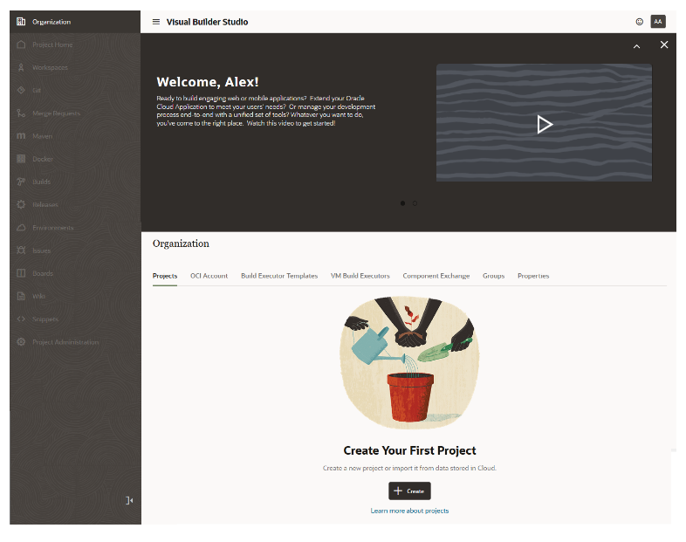
After client create the instance:
- Client assigned the DEVELOPER_ADMINISTRATOR IDCS role, which enables client to set up VB Studio, manage the VM build executors, and update the organization details. After client assigned the role, client also called the VB Studio's Organization Administrator.
- Client receive an email with the subject Verify client Oracle Visual Builder Studio email. Open the email and click the URL link in the email body to verify client email. This is required to receive email notifications from the service.
After verifying the email address, client receive another email with the subject Welcome to Oracle Visual Builder Studio. This email contains the VB Studio URL that client can bookmark.
- Default tags are created that help client identify the instance. On the VB Studio's Instance Details page, click the Tags tab to see the created tags. If client don't know how tags help.
- Provide access for additional users.

Access VB Studio from the Oracle Cloud Home Page

If client signed out of the Oracle Cloud or VB Studio, follow these steps to sign back in.
- In a web browser, go to https://cloud.oracle.com.
- On the Sign-In page, in Cloud Account Name, enter client Oracle Cloud account or tenancy name and click Next.
- On the Single Sign-On (SSO) panel, if required, select client identity provider and click Continue.
- Enter client Oracle Cloud account credentials and click Sign In.
The Oracle Cloud Console, also called the OCI console, opens. If client recently created client Oracle Cloud account, wait for some time to see client services in the Oracle Cloud Console.
- In the upper-left corner, click Navigation Menu .
- Select Developer Services and then select Visual Builder Studio.
- On the Visual Builder Studio Instances page, click the VB Studio instance's name.
- On the Instance Details page, click Service Console.
The VB Studio Organization page opens, which displays all the projects client a member of, as well as client favorite projects, the projects client own, and all the shared projects in client organization.
Here's an example of the Organization page with some projects:
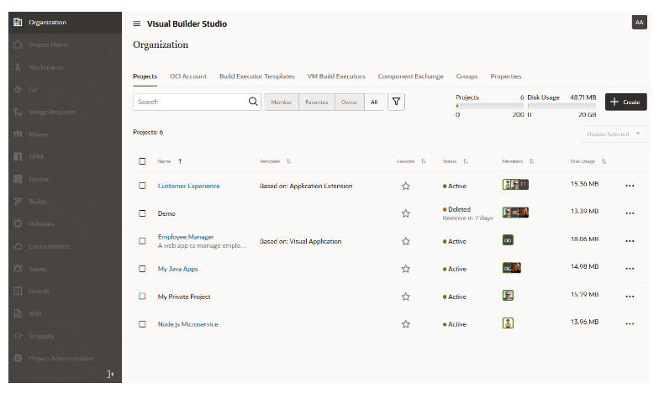

Manage the VB Studio Instance
After creating the VB Studio instance, client change the CI/CD compartment and the instance's display name, but can't change the name displayed in the instance's URL.

Manage VB Studio Instance Tags

OCI tags enable client to tag client OCI resources, such as client VB Studio instance, and help client organize resources based on client business needs. Client can manage VB Studio tags from the VB Studio Instance Details page.
If client new to OCI tags,
Action | How To
Add a tag | - On the VB Studio Instance Details page, click Add Tags.  - In the Add One Or More Tags To This Resource dialog box, enter the tag's namespace, key, and value.  - Click Add Tags.
Edit a tag | - On the VB Studio Instance Details page, click the Tags tab.  - To edit a tag, click its Edit icon.  - In the Edit Tag dialog box, edit the tag and click Save.
Remove a tag | - On the VB Studio Instance Details page, click the Tags tab.  - To edit a tag, click its Edit icon.  - In the Edit Tag dialog box, click Remove Tag.

Terminate the VB Studio Instance

When client terminate client VB Studio instance, all projects and their data (such as Git repositories, workspaces, build jobs, and build artifacts) are deleted. OCI resources, such as VM executors, are destroyed and OCI Object Storage buckets are deleted too.
- Open the Visual Builder Studio Instances page and click the VB Studio instance.
- Click Terminate.
- In the Confirm dialog box, enter the VB Studio instance's name and click Terminate.
Wait for some time. OCI takes a few minutes to terminate the VB Studio instance.

Get a VB Studio Project's Identifier

Each VB Studio project has a unique identifier that client can get and copy from the Project Administration page if client are the project owner or, if client are a project member, from the Git or Maven URLs on the Project Home page.
The project identifier can be used with the OCI Resource Manager API at https://docs.oracle.com/iaas/api/#/en/resourcemanager/20180917/. It is used in URLs when working with the project's Git repositories and branches.
If client a project owner, select Project Administration in the navigator, click the Properties tile, then look in the Identifier field to find project identifier. Click to copy the ID to the clipboard.
If client a project member, go to the project's Project Home page, click on the Repositories tab, and examine the details of the Maven or Git repository URL. Look for the part before /maven/ or /scm/repository-name.git at the end. Some project identifiers may also include a numeric value appended to the project name. Click to copy the URL to the clipboard.

Set Up VB Studio for CI/CD

The build system in VB Studio enables client organization's developers to create jobs to build, package, test, and deploy apps.
To build their applications, client organization's developers define build jobs in their VB Studio projects. A job is a configuration that defines where the application's source files are, commands to run, how to generate and package artifacts, run test scripts, and where to deploy the application's artifacts.
To run builds of jobs, client organization's developers need some compute instances with operating systems and software packages installed. For example, to build Node.js applications, they'll need Node.js installed on an OCI VM compute instance and use it to run their CI/CD builds.

What are Build Executors and Build Templates?

Builds in a build system run in build executors. The operating system and software packages required to run builds on build executors are defined in build templates.
In VB Studio, builds run either in VM build executors (VM executors, for short) or in Docker executors. Build executor templates define the operating system and software packages for VM executors, and Docker images define the operating system and software packages for Docker executors.
Before client developers create jobs and run builds, client must decide whether to run client organization’s builds on VM executors or on Docker executors, and then create the required resources. To help client decide, learn what VM executors and Docker executors are, how builds run on them, and the differences between both executors.

Build Executor Templates

A build executor template defines the operating system and the software packages client organization's members need to run builds on VM executors.
VB Studio offers some executor templates out-of-the-box that client organization's users can use. Client can create more executor templates if the default executor templates don’t meet client requirements.
Some key points to remember about executor templates:
- Each executor template contains an Oracle Linux operating system, Java and some required software packages. If required, client can install more software packages available in the VB Studio Software Catalog.
- Client can't add a software package or a version that's not available in the VB Studio Software Catalog.
- In the Software Catalog, some software packages have multiple versions. Client can add only one version to the executor template. However, client can add multiple versions of Java to an executor template.
- Executor templates don't consume storage space or increase client cost. Client can create as many executor templates as client require.
- Some software packages, such as Fn and Oracle Jet, require other software packages in the same executor template. When client add these software packages, VB Studio prompts client to add the dependent software packages.
- Don't add unnecessary software packages to an executor template. The more software packages client add to an executor template, the more storage space its VM executors consume when they run builds.

VM Build Executors

VM build executors are OCI VM compute instances dedicated to run builds of jobs client organization’s members define in VB Studio projects.
A VM executor is always associated with a build executor template. When client organization's members create jobs, they simply associate the appropriate executor template with the job. When the job's build triggers, VB Studio runs the build on a VM executor that's associated with the executor template.
A VM executor starts automatically when a build of a job that references its executor template triggers, and changes its state accordingly. Remember, a VM executor costs client only when it is active, runs a build, or is preparing itself to run a build.
Some key points to remember about VM executors:
- After creating a VB Studio instance, if no VM executors exist, VB Studio creates a VM executor when client create client first project. The VM executor is associated with the System Default OL7 for Visual Builder executor template in the connected OCI account.
- When client add a VM executor manually, client must specify the executor template, choose an OCI region from the connected OCI account's subscribed regions, specify the OCI Compute VM's shape, and select the VCN (optional).
- Client OCI account may have some Compute instance limits set. When client add a VM executor, VB Studio looks into the specified OCI region's Availability Domains, finds available OCPUs with the specified shape, calculates the number of Compute instances, and displays the number of Compute VM instances client can add from client OCI account's set limit.
Here's an example of the VB Studio's Add VM Build Executors dialog box that displays the number of VM executors client can add with the VM.Standard.E2.1 shape:
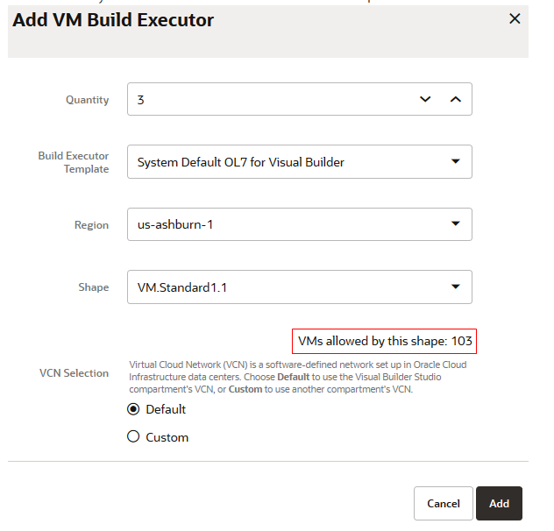
- When client add a VM executor, it is added in the Pending state and doesn't cost client. Client can add more VM executors than the number of available Compute VM instances.
Remember, VB Studio creates a Compute VM instance when a VM executor starts, not when client add it.
- Client can add standard and legacy VM shapes with these series:
  - VM.Standard1
  - VM.Standard2
  - VM.Standard.E2
  - VM.Standard.E3.Flex
  - VM.Standard.E4.Flex
  - VM.Standard.B1
- A VM executor can run one build at a time.
- When a job's build runs, if VB Studio finds multiple VM executors allocated for the job's executor template, it runs the build on any one of them. Client can't choose or specify a particular VM executor to use for the build.
- If client expect client organization's members to run parallel builds of jobs that refer to a common executor template, add multiple VM executors for that executor template. If client not sure, client can start with one VM executor and add more VM executors later.
- While adding multiple VM executors that reference a common executor template:
  - Add all VM executors in the same VCN. If client add VM executors with a common executor template in different VCNs (such as some VM executors in the default VCN and other VM executors in a custom VCN), client builds might behave unpredictably.
  - Add all VM executors with the same shape. If client add VM executors with different shapes (such as some VM executors of the VM.Standard1.1 shape and some of the VM.Standard2.8 shape), client builds may run slow or fast depending on the VM executor it runs on.
- After a build is complete, a VM executor continues to be in the Available state and waits for some time for any queued builds. This wait time is called sleep timeout. If no builds run on the VM executors in this duration, VB Studio automatically stops the VM executors.
- The more VM executors client have running at a specific time, the higher the cost. To minimize the higher cost, configure the sleep timeout to stop inactive VM executors after some time. The sleep timeout setting applies to all VM executors of client organization.

What Happens When a Build Runs in a Build Executor?

When VB Studio runs a build, it follows a set order to select a VM executor. Client can't choose or specify a particular VM executor to use for the build. If no VM build executors are found, VB Studio fails the build.
When multiple VM executors are found, VB Studio selects a VM executor to run the build in this order:
- If a VM executor is in the Available state, VB Studio runs a build on it.
- If no VM executors are in the Available state, VB Studio starts a Stopped VM executor, installs the operating system and the executor template's software packages from the saved boot volume, and then runs the build on it.
- If no VM executors are in the Available or the Stopped state, VB Studio starts a Pending VM executor, installs the operating system and the executor template's software packages, and then runs the build on it.
- If all VM executors are running builds, VB Studio waits for a VM executor to complete its build, and then runs a build on it.
Note
A VM executor in the Stopped or Pending state will take several minutes to start because VB Studio installs the operating system and the executor template's software packages before running the build.
The VM executor should start subsequent builds more quickly. Client can adjust the sleep timeout to avoid start-up delays.
The steps for a build running in a build executor include:
- VB Studio checks the job's build executor template and then finds a VM executor allocated to it.
- VB Studio checks the job's configuration and runs the commands in the specified order.
- After the build is complete, VB Studio copies any generated artifacts to the configured OCI Object Storage bucket.
- The VM executor waits for some time for any queued builds. If no builds run during the wait time period, the VM executor stops.
Before stopping the VM executor, VB Studio saves the operating system and software packages to the VM executor's assigned boot volume.

VB Studio's Free VM Build Executor

The free VM build executor is available in the VB Studio's built-in free account and runs on VB Studio's default VCN.
Note
The free VM build executor feature is available only for Commercial OC1 realm regions.

A VM executor can run only one build at a time. The more VM executors client have available, more builds client organization's members can run at the same time. As the built-in free account offers only one VM executor, client VB Studio organization members can run only one build at a time. If members trigger multiple builds while a build is already running, they must wait until the build running on the VM executor is complete. The VM executor then runs the queued builds on a first-come-first served basis.
The default executor template, called System Default OL7 for Visual Builder, includes the necessary software to run extension and visual application builds. Client can't change the default executor template's configuration.

Run VM Build Executors in Virtual Cloud Network

A Virtual Cloud Network (VCN) is a software-defined network that client set up in the OCI data centers of a region. A subnet is a subdivision of a VCN. A VM build executor always runs in a VCN's public subnet.
Client can choose to run a VM executor in the VB Studio compartment's VCN or in another compartment's VCN. Run the VM executor in the VB Studio compartment's VCN if client don't have a VCN or want to use the default option without any additional configuration. Run the VM executor in another compartment's VCN if client want the VM executor to access Oracle Cloud services running in that compartment's VCN.
Note
Client can't run VM executors in a VCN if VB Studio is connected to the built-in free account. To use another compartment's VCN, configure VB Studio to connect to an OCI account.
VB Studio compartment's VCN, also called the default VCN, is automatically created for client when the first VM build executor that uses it starts.
VB Studio's default VCN is called vbs-executor-vcn and resides in the VB Studio's compartment. When a VM executor that uses the default VCN starts, VB Studio checks the OCI compartment for the default VCN. If it doesn't exist, VB Studio creates a VCN called vbs-executor-vcn with CIDR block 10.0.0.0/16 and public subnets in all availability domains. If the VCN exists, VB Studio uses it to run client VM executors.
When VB Studio creates the default VCN, it also creates these components and adds them to the VCN:
- An Internet Gateway
- A Route Table that uses the Internet Gateway as the routing rule
- Security Rule Ingress rules that allow TCP traffic on:
  - Destination port 22 (SSH), 9003 (Executor agent debug), 9005 (VM agent debug), 9082 (Executor agent), and 9085 (VM agent), and 8095 (Docker Agent), and 9001-9010 from source 0.0.0.0/0 and any source port.
  - Destination port 443 from sources in the 10.0.0.0/16 IP range.
- A Security Rule that allows Egress to any destination from any protocol.
- Three public subnets, one for each availability domain. Their CIDR is set to 10.0.0.0/24, 10.0.1.0/24, and 10.0.2.0/24.
Here's an example of the default VCN:
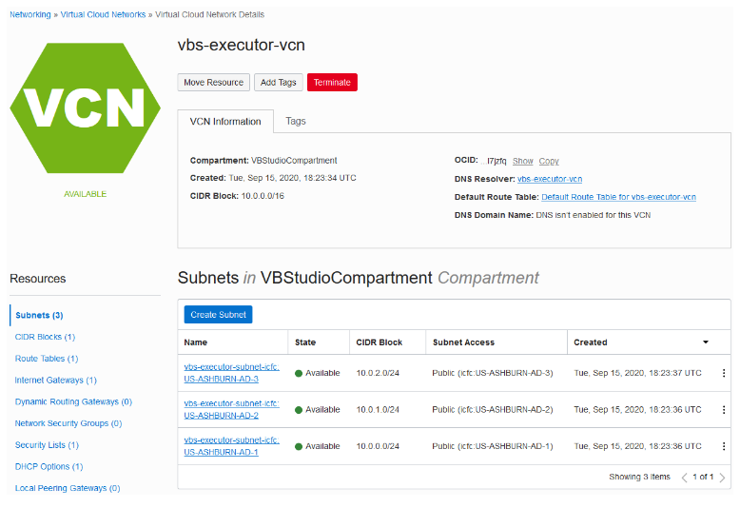
As soon as the default VCN is available, client have full control over it and can modify it. Client can add private subnets for client private services, add more public subnets or delete the existing subnets, modify security lists, and add or remove other components.
Note
- When a VM executor runs on the default VCN, it runs on any of its available public subnets. Client can't specify which subnet it should run on.
- If client plan to remove some public subnets of the default VCN, make sure that at least one public subnet is available in the VCN. If there are no public subnets, VM executors in the default VCN won't run and client builds will fail.
- The default VCN is created once and continues to stay until it is deleted manually.
- If client organization's members configure jobs that access Oracle Cloud services in the private or public subnets of the VCN, ask them to configure their jobs to access the services using private IPs or Fully Qualified Domain Name (FQDN).

Run VM Build Executors in Another Compartment's VCN and Subnets
To allow a VM build executor access client Oracle Cloud services in a compartment's VCN, client should configure the VM executors to run in the same VCN. This allows the VM executor to access Oracle Cloud services easily without any complex networking configuration.
Before client configure the VCN, make a note of these:
- A VM executor always runs in a public subnet.
- In the VCN, client must create a public subnet or configure an existing public subnet to allow inbound access from and outbound access to VB Studio.
- Make sure that the public subnet is regional.
- Instead of modifying an existing security list's security rules, create a new security list for the public subnet.
For the public subnet, create a security list and add ingress rules from source CIDR 0.0.0.0/0 for VB Studio ports 22 (SSH), 9082 (Executor Agent), and 9085 (VM Agent). This is required to allow VB Studio access the VM executors in the VCN.
- For the subnet's compartment, assign the use virtual-network-family OCI policy to the user whose OCID client specified in Set Up the OCI Connection in VB Studio. This is required for networking permissions and builds to run in the VCN's subnet. This statement assigns the policy to the user's group:
allow group <group-name> to use virtual-network-family in compartment <subnet-compartment-name>
Here's an example of the use virtual-network-family policy added to the policies client created in

Set Up the OCI Account
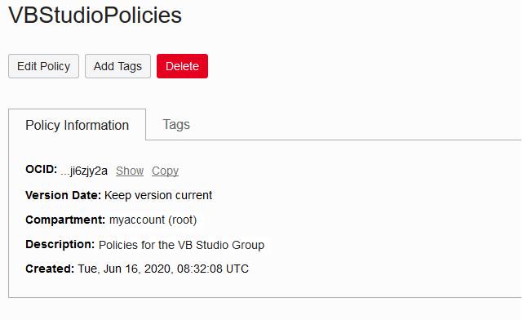
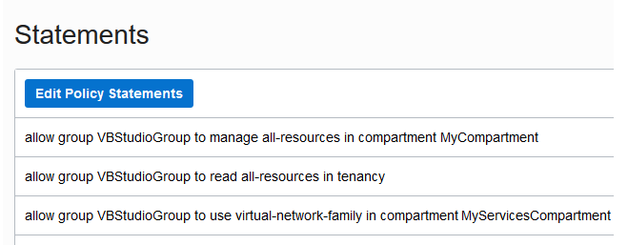
- Make sure that the VCN has a route table with a rule that allows Internet access.
- To allow the VM executor to access the VCN's private subnet's services and resources, configure the private subnet's security rules to allow incoming traffic from the public subnet used by the VM executor.
- While adding a VM executor, client can specify multiple public subnets. If VB Studio can't create the VM executor on the first specified public subnet, it tries to create it in the second subnet, and so on.
- After configuring a VM executor to run in another compartment's VCN, ask client organization's members to configure their build jobs to use the private IP addresses or the Fully Qualified Domain Name (FQDN) of services that are running in the VCN.

This table describes what client need to do if client have a VCN.
If ... | Then :
Client have a VCN without a public subnet | Create and Configure a Public Subnet in a VCN.Client also configure the subnet's security list to allow inbound access from and outbound access to VB Studio.  - To allow a VM executor access a service running in the private subnet, configure the private subnet's security list.
Client have a VCN with a public subnet | - In client VCN, create a security list with ingress rules and egress rules as described in steps 6-11 of Create and Configure a Public Subnet in a VCN.  - Open client public subnet's details page and add the security list.  - To allow a VM executor access to services running in the private subnet, configure the private subnet's security list. Add and Manage VM Build Executors in the VCN.
Client don't have a VCN and want to create one | - Use the VCN wizard to create a VCN with a public subnet and an internet gateway.  Create and Configure a Public Subnet in a VCN.Client also configure the subnet's security list to allow inbound access from and outbound access to VB Studio.  - To allow a VM executor access to services running in the private subnet, configure the private subnet's security list.  - Add and Manage VM Build Executors in the VCN.

Tell them not to use public IP addresses, because when VM executors are in the same VCN as the service, public IP addresses will route the traffic outside the VCN, causing builds to fail.

Create and Configure a Public Subnet in a VCN
Before client can run VMs in another compartment's VCN, client must first create a public subnet in client VCN with security rules that allow inbound access from and outbound access to VB Studio.
- Sign in to Oracle Cloud Console.
- In the upper-left corner, click Navigation Menu .
- Select Networking and select Virtual Cloud Networks.
- Under List Scope, select the compartment.
- From the VCNs list, click the VCN's name.
- Under Resources, click Security Lists, and then click Create Security List.
- In Name, enter a name for the security list.
- In Create in Compartment, ensure that the correct compartment is selected.
- In Allow Rules for Ingress, click + Another Ingress Rule and follow these steps:
  - In Source Type, select CIDR.
  - In Source CIDR, enter 0.0.0.0/0.
  - In Destination Port Range, enter 9082.
  - (Optional) In Description, add a description.
Here's an example:
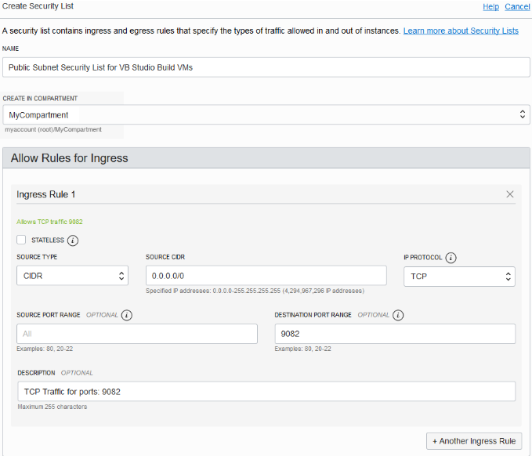

  - Click + Another Ingress Rule and repeat steps from 9.a to 9.d to add ports 9085 and 22.
  - (Only if client are using Docker executors) Click + Another Ingress Rule and repeat steps from 9.a to 9.d to add ports 8095 and 9001-9010 to 0.0.0.0/0 and add port 443 to client VCN CIDR (for example 10.0.0.0/16).

- In Allow Rules for Egress, click + Another Egress Rule and follow these steps:
  - In Source Type, select CIDR.
  - In Source CIDR, enter 0.0.0.0/0.
  - In IP Protocol, select All Protocols.
  - (Optional) In Description, add a description.
- Click Create Security List.
After creating the security list, click its name to verify the ingress and egress rules client added.
Here's an example of ingress rules:
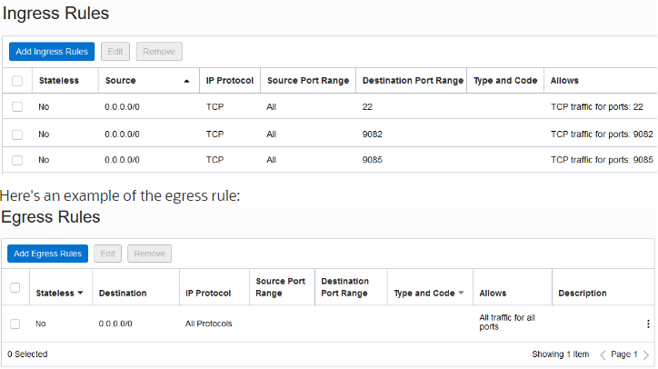
- Return to the VCN's details page.
- Under Resources, select Subnets and follow these steps to create a public subnet:
If client want to edit an existing public subnet, jump to the next step.
  - Click Create Subnet.
  - In Name, enter the subnet's name.
  - In Create in Compartment, select the correct compartment.
  - In Subnet Type, make sure that Regional is selected.
  - In CIDR Block, enter the subnet's CIDR block.
Don't set it to 172.17.0.0/16 as it's the default subnet allocated to Docker.
  - In Route Table, select the VCN's route table.
  - In Subnet Access, make sure that Public Subnet is selected.
  - In DHCP Options, select the VCN's DHCP options.
  - In Security List, select the security list client created in Step 6.
  - Fill in the other fields as required.
Here's an example:
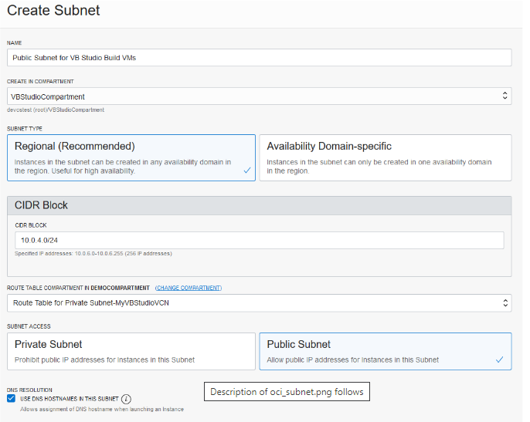
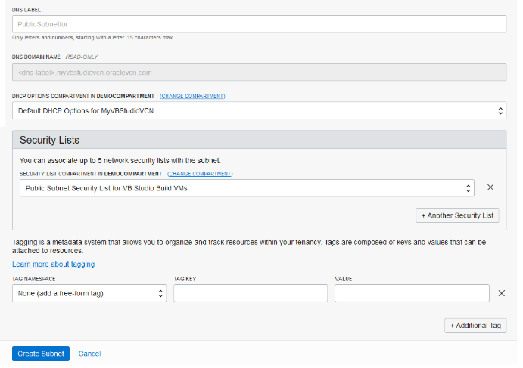

  - Click Create Subnet.
- If client want to edit an existing subnet, follow these steps:
  - Under Resources, select Subnets and click the public subnet's name.
  - Click Add Security List.
  - In the Add Security List dialog box, in Security List, select the security list client created in Step 6.
  - Click Add Security List.
That's it. After creating or editing the public subnet, client VM executors can now run in the VCN.

Allow VM Build Executors to Access a Private Subnet's Resources
After adding a public subnet in a VCN, to allow VM build executors access the resources and services (such as Java Cloud Service or a VM-based Database) running in the VCN's private subnet, configure the private subnet's security rules to allow incoming traffic from the public subnet used by VM executors.
For example, to allow VM executors access Java Cloud Service running in a private subnet, configure the subnet's security list to add the VM executors CIDR ranges to the Ingress rule associated with the JCS Admin port.
- Sign in to Oracle Cloud Console.
- In the upper-left corner, click Navigation Menu .
- Select Networking and select Virtual Cloud Networks.
- On the Virtual Cloud Networks page, click the VCN.
- Under Resources, click Security Lists, and then click the private subnet's security list.
- Click Add Ingress Rules.
If client want to modify an existing rule, click the Actions icon (three dots), and then select Edit.
- In Source Type, select CIDR.
- In Source CIDR, enter the VM executor's public subnet's CIDR range.
- In Destination Port Range, enter the service's port number.
- (Optional) In Description, add a description.
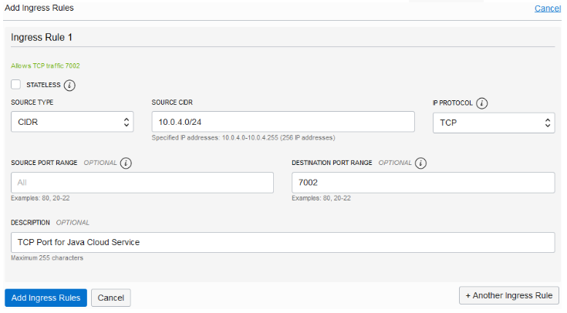
- Click Add Ingress Rules.
- If required, repeat steps from 6 to 11 for each service's port.

VB Studio Public IP Addresses in OCI Data Centers
If client running VM executors in another compartment's subnet and don't want to use the CIDR 0.0.0.0/0 range in client ingress and egress rules, specify VB Studio's public IP address in the subnet's ingress and egress rules.

********END********

